**Will high inflation and interest rates bring the US economy into a recession?**

**Findings on Inflation and Interest rates**

The above data shows the federal funds rate, change in Personal Consumption Expenditure (PCE) Index and Core Consumer Price Index (CPI) in percentage. The above PCE and CPI in % is calculated by the change over a period of 1 year.

From the start of 2020, the federal funds rate was below PCE and CPI, indicating a expansionary monetary policy from the Federal Reserve. From April 2020 to February 2022, interest rates remained close to 0 as the Federal Reserve stimulated the economy during covid. From February to April 2021, inflation data showed a jump of 67% and 70% for PCE and, 64% and 63% for CPI in a 2 month period. This jump of 2 months continued in a steep upward trend till June 2022.

The Federal Funds Rate is close to CPI but is 2% away from PCE. This indicates the Federal Reserve has to continue increasing interest rates to reduce the broader level of inflation. The graph below shows a downward trend in inflation. The Fed Funds rate is currently above PCE and below CPI.

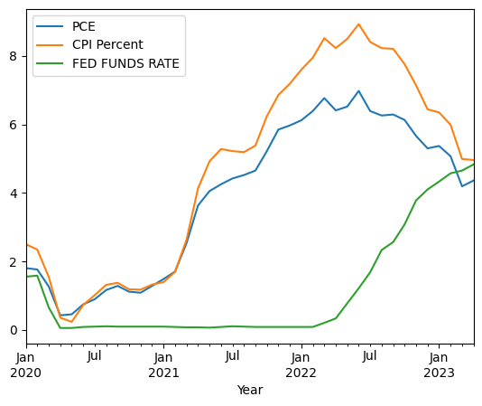

Comparing to great recession on 2007-2008, Federal Funds rate currently near the levels of the the dotcom bubble and the great recession.

As shown in the chart below, the Federal Reserve responded to the 2001 Dotcom bubble crisis by lowering interest rates and maintained rates low through 2004. Similar to Covid Pandemic, interest rates was reduced to almost 0 from mid 2020 till early 2022.

Both crisis, beforehand, saw a rise in inflation and the Federal Reserve thereafter, increasing the nominal interest rates to control inflation. From July 2006 to June 2007, interest rates were held at 5.25% over a one year period and soon after on October 2008, saw a drop in PCE and CPI indicating a recession has occurred.

The global financial crisis was due to Mortgage Backed Securities becoming toxic assets. Some factors leading to toxic MBS were:

1. Low interest rates that led to increase in borrowing
2. Increase in delinquency rates due to low credit ratings for housing mortgages

Data is showing a similar trend that led to a financial crisis. We are seeing high inflation and thereafter, high interest rate.

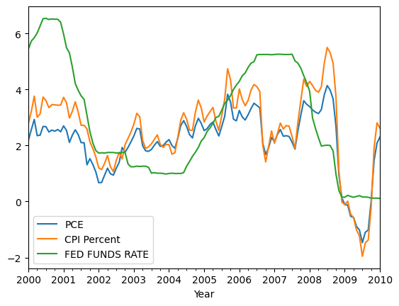

**Strength of the USA economy and comparing to 2007/08 Global Financial Crisis.**

In this high interest rate environment due to inflation, comparing Unemployment Rates, Job Openings, PCE, Retail Sales and business Inventory can give us a view of strength of the current economy and before the 2007-2008 global financial crisis.

From 2004 to 2006, job openings were on an upward trend, as shown in the graph below. It started to moderate in the middle of 2007 and started a downward trend at the end of 2007. Employment rate mantained at a steady upward trajectory throughout until early 2008 when both job openings and employment rate fell, highlighting a recession has occurred.

From 2020 to May 2023, the job openings are showing an upward trend. While it has come down from its high in early 2022, it is still higher than previous years. Employment rate has also increased at a steady pace, similar to data shown from 2004 to mid 2007. This is negative news for inflation.

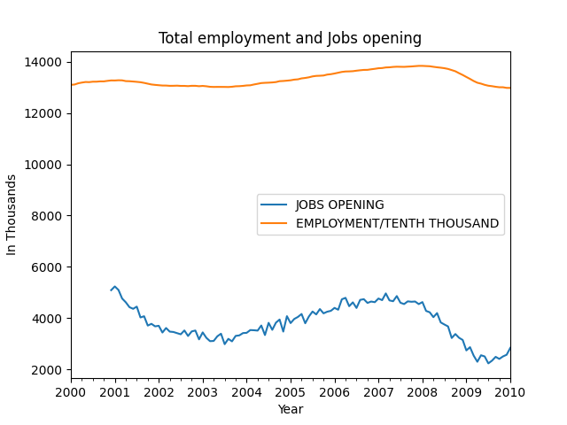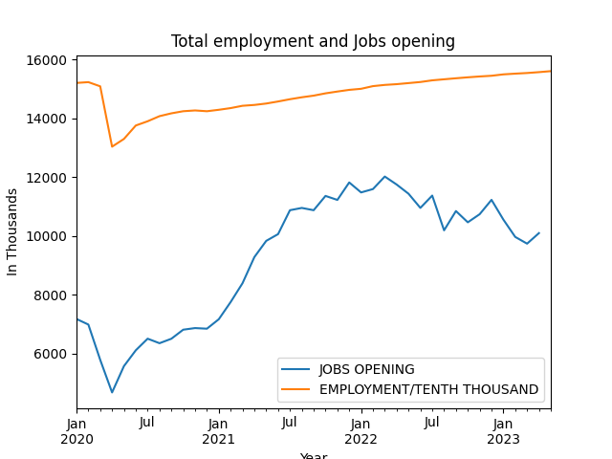

Unemployment rate started rising from December 2007 at 4.7% to a peak of 10% in October 2009. It was the same period when job openings fell. Current unemployment is well below what was seen before the 2007/08 financial crisis and has remained horizontal at 3.4 to 3.8% since February 2022.

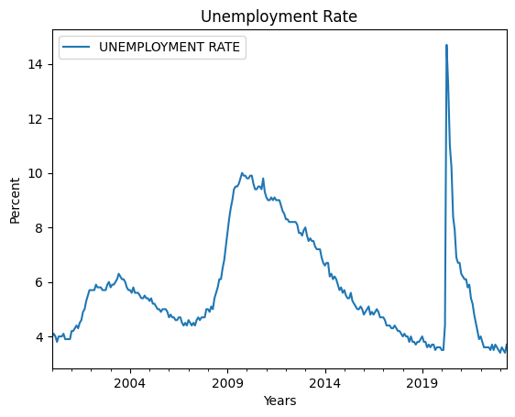

Looking at retail sales and inventories, data shows a flattening in retail sales since march 2022. However, there has been a build up in retail inventories since that period. Looking at the inventory to sales ratio, from November 2021 to March 2023, inventory to sales ratio has been increasing from 1.13 in November 2021 to a peak of 1.30 in December 2022 and March 2023. This is a positive for bringing inflation down.

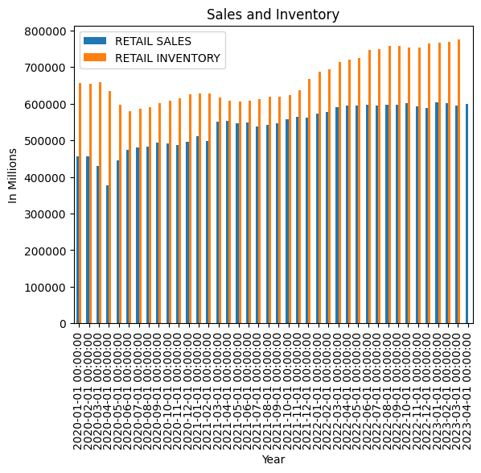

**Consumer’s financial health**

In a high inflation environment, there will be a strain to consumers spending. Looking at personal savings, we can see consumer’s behaviour towards spending and saving. Personal savings’ data used is calculated with personal income less personal outlays and personal taxes.

Personal savings data shows a steep decline from covid highs of 33.8 and a low of 2.7 in June 2022. Current personal savings is at 4.1. This level has not been met since the global financial crisis of 2007/08 and year 2005 leading to the global financial crisis, ranging from 2.1 to 4.1. This is positive news for inflation.

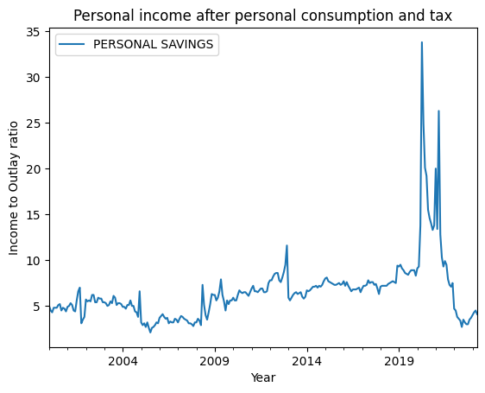

As for consumer loans and residental real estate loans, we are seeing similar upward trend on loans being given out to consumers. Similar trend from before the great recession on 2007/08, we are seeing a steeper rise on housing mortgages. This similar trend is due to a expansionary monetary policy where interest rates was near 0.

Consumer loan has seen a steeper rise than 2007/08 and showing no signs of moderation. Interst rates loans have an inverse relationship. As interset rates incerases, the level of credit consumers are willing to borrow should decrease. This is showing a convergence in their relationship.

With an increase in consumer loans and housing mortgages, taking a look into delinquency rates on both categories can show us credit risk that banks could face.

Prior to 2007/08 financial crisis, delinquency rate for housing mortgages saw a steep increases every month, starting from april 2007 to Jan 2009. The left data is the % change every month on housing mortgages delinquency rate. From April 2007, there was a steep increase of 10% in housing mortgage delinquency rate. This continued through to the first quarter of 2010 and it reached a peak of 24% on October 2008.

Consumer loans saw a rise in delinquency rate. Delinquency rates started increasing on Jan 2006 before starting to see a steep upward trajectory on April 2007 to April 2009, similar time when housing mortgages started to default, before consumer loan delinquency rate started to taper down on July 2009.

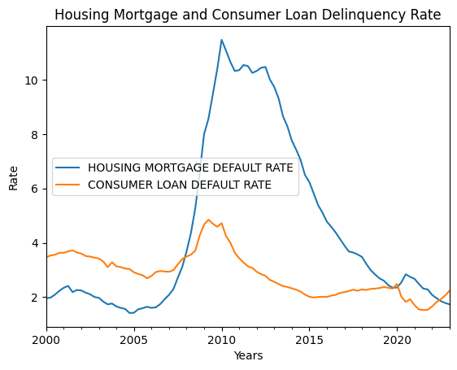

In conclusion, the current economic landscape in the United States presents a mixed picture. While the PCE levels remain below the federal funds rates, indicating the need for a restrictive monetary policy to bring down inflation, the overall strength of the US economy is evident. The economy continues to exhibit robust indicators such as high employment rates, job openings, and retail sales. However, it is essential to consider the lessons from the past, particularly the period from early 2006 to mid-2007 when interest rates were held above 4%. This restrictive monetary policy constrained businesses, leading to cost-cutting measures, lower job openings, and higher unemployment rates. If the Federal Reserve were to pursue a similar high-interest-rate environment, it could impede economic growth and prompt companies with short-term debts and upcoming long-term loan payments to adopt conservative approaches, potentially resulting in increased unemployment.

Notably, retail sales have plateaued since March 2022, and a recent buildup in inventory suggests that consumers may have reached their peak consumption of retail goods. This divergence between demand and supply, along with the slowdown in demand caused by the restrictive monetary policy, indicates a downward trend in inflation. This provides the Federal Reserve with more flexibility in determining its future monetary policy approach.

It is concerning to observe an increase in loans coupled with a decrease in personal savings, drawing parallels to the period before the 2007/08 financial crisis. Current personal savings levels resemble those seen in 2005 before the crisis hit. High inflation has compelled consumers to tap into their savings while facing difficulties setting aside funds for future saving. As consumer spending habits shift toward a more conservative approach, an increase in personal savings and a further decrease in inflation could be expected.

Looking at housing mortgages and consumer loans, similar trends are emerging. Housing mortgages experienced a steep increase from 2006 to 2008, followed by a sharp decline. Presently, housing loans show a notable upward trajectory. Consumer loans, on the other hand, have seen a steeper increase since the COVID-19 pandemic compared to the data from the 2007/08 financial crisis.

Analyzing defaults on housing mortgages and consumer loans, there is an inversion in risk. The decrease in housing mortgage defaults indicates a lower likelihood of a banking crisis similar to the one experienced in the United States. However, the increasing default rates on consumer loans, reaching 9.7% in January 2023, suggest the potential for a credit crisis should the unemployment rate rise while personal savings remain at levels seen during the 2007/08 crisis. Despite the increase in consumer loan defaults, they still remain below the levels observed before and during the financial crisis.

In summary, the current economic environment presents a complex situation where the need for a restrictive monetary policy to control inflation intersects with a strong US economy. The risk of a recession is not evident yet with the current data at hand but, the divergence in demand and supply, changin consumer spending habits, and the potential for credit crisis warrant close monitoring and appropriate policy responses to ensure sustainable economic growth and stability.Top of Form